Cover Page



**Project Report**

**ArchiTech**

**Team Members**

Joshua Grubbs

joshua.grubbs01@gmail.com

Kenneth Ngo

kpngo102@gmail.com

Ken Tran

kenkhiemtran13@gmail.com

Leonard Reyes

leonardreyes6@gmail.com

Sung Lee

Sunghuyn3772@gmail.com

Vision Document

Vision Document – ArchiTech

**I. Problem Statement**  
Building a custom PC can be an exciting project, especially for gamers and hardware enthusiasts. However, many users face significant challenges when selecting parts and visualizing the final product:

* **Lack of Visual Feedback:** Most PC part picker tools show compatibility in list form, but do not offer a 3D visualization of how the final build will look.
* **Fitment Issues:** Users may choose parts that do not physically fit inside the case (e.g., GPU too long, CPU cooler too tall), leading to returns or unexpected changes during assembly.
* **Complexity for Beginners:** New builders may feel overwhelmed with component selection, compatibility checks, and understanding spatial layouts.
* **Limited Prototyping Tools:** There are few or no mobile apps available that allow users to design, visualize, and interact with a virtual PC build in real time.
* **Saves time, effort, and money:** Buying incompatible components often leads to wasted money and time due to shipping delays, restocking fees, or returns.

**II. Main Features**  
**ArchiTech** aims to eliminate these challenges by providing a robust, user-friendly mobile app that allows users to create and preview a custom PC in 3D with the following capabilities:

* Create an account and start a new build project
* Browse a library of real PC components (cases, CPUs, GPUs, RAM, PSU, etc.)
* Drag-and-drop parts into a 3D case environment
* Real-time compatibility checks and alerts for clearance issues
* Rotate, zoom, and inspect the full 3D PC build
* Filter parts by compatibility, brand, form factor, and size
* View technical specs for each component
* Save and return to builds later
* Share build previews or part lists with others
* Export build summary (price, power draw, compatibility notes)
* Future expansion: AR preview mode and performance benchmarking

**III. User Benefits**  
ArchiTech provides significant value for its target users by enhancing their planning process and reducing uncertainty.  
**1) New Builders:**

* Confidence Boost: Visual previews reduce anxiety over fitment and compatibility as they can see it clearly compared to looking at technical specs on a manual
* Learning Tool: Interactive layout shows how components fit and function together giving new builders a better understanding of the basics.
* Guided Selection: Filters and compatibility warnings simplify decision-making.

**2) Experienced Builders:**

* Efficient Planning: Quickly test build ideas without trial and error of having to do it in person.
* Design Customization: Experiment with part aesthetics and layout before purchasing.
* Build Sharing: Save and share configurations with friends or communities.

**3) All users:**

* Reduced Costly Errors: Prevent buying mismatched or oversized components.
* Enhanced Experience: Makes the PC building process more interactive and enjoyable.
* Convenience: Mobile-based access allows planning from anywhere at any time.

Project Report - Use Case Description

**Brief Use Case Description Table**

| Use Case | | | | | | Brief use case description | | | | | | | | | | | | | |
| --- | --- | --- | --- | --- | --- | --- | --- | --- | --- | --- | --- | --- | --- | --- | --- | --- | --- | --- | --- |
| Create account | | | | | | User enters personal details (name, email, password), and the system validates input, creates a new user profile, and stores credentials for future login. | | | | | | | | | | | | | |
| Login | | | | | | User inputs email and password, and the system verifies credentials, initiates a session, and grants access to saved builds and features. | | | | | | | | | | | | | |
| Logout | | | | | | User selects the logout option and the system ends the session, clears temporary data, and returns the user to the login screen. | | | | | | | | | | | | | |
| Delete Account | | | | | | User confirms deletion, and the system removes all personal data from the database. | | | | | | | | | | | | | |
| Premium Subscription | | | | | | User selects a subscription plan, provides payment info, and the system activates premium features, updates user status, and stores subscription date. | | | | | | | | | | | | | |
| Cancel Subscription | | | | | | User cancel their plan and the system marks the account as non-premium while maintaining access until the current period expires. | | | | | | | | | | | | | |
| Start New Build | | | | | | User clicks “new build” and the system initializes a blank 3D canvas, prompting selection of a PC case and component categories. | | | | | | | | | | | | | |
| Add Component | | | | | | User selects a component from a list and the system places the part into the 3D model while checking compatibility and alignment. | | | | | | | | | | | | | |
| Remove Component | | | | | | User selects a component already placed and the system removes it from the current build and updates the compatibility rules. | | | | | | | | | | | | | |
| Load Build | | | | | | User selects a saved build and the system retrieves build data and populates the 3D model with all saved components. | | | | | | | | | | | | | |
| Save Build | | | | | | User clicks “save” and the system stores the current build configuration under the user’s profile. | | | | | | | | | | | | | |
| View 3D Build | | | | | | User interacts with the assembled PC in 3D and the system renders the full build with rotation, zoom, and visibility controls. | | | | | | | | | | | | | |
| Check Compatibility | | | | | | The system automatically checks current components for socket match, size clearance, power demand, and other technical fit rules, displaying warnings when needed. | | | | | | | | | | | | | |
| Receive Component Warning | | | | | | System displays alerts with messages when a newly added part conflicts with the build due to dimension, socket, or power mismatch. | | | | | | | | | | | | | |
| Share Build | | | | | | User generates a shareable link or code for the current build and the system packages the build data and creates a unique build reference. | | | | | | | | | | | | | |
| Comment on Shared Build | | | | | | User adds a comment to a shared build and the system links it to the shared build thread and updates the build owner with feedback notifications. | | | | | | | | | | | | | |
| Rate Shared Build | | | | | | User assigns a rating to another user’s shared build and the system records the rating and updates the build’s public score. | | | | | | | | | | | | | |
| Build Summary | | | | | | User clicks summary, and the system generates a report with a list of parts, specs, wattage, estimated cost, and compatibility notes. | | | | | | | | | | | | | |

| AR Preview (Premium) | | | | | | User enable camera access on the app, and the system overlays the 3D build onto real-world space using AR technology to preview physical placement and dimensions. | | | | | | | | | | | | | |
| --- | --- | --- | --- | --- | --- | --- | --- | --- | --- | --- | --- | --- | --- | --- | --- | --- | --- | --- | --- |
| AI Recommendations (Premium) | | | | | | User clicks on “suggest parts,” and the system analyzes current build data and user goals to recommend optimized parts based on cost/performance/value | | | | | | | | | | | | | |

Use Case Diagram

**Use Case Diagram**

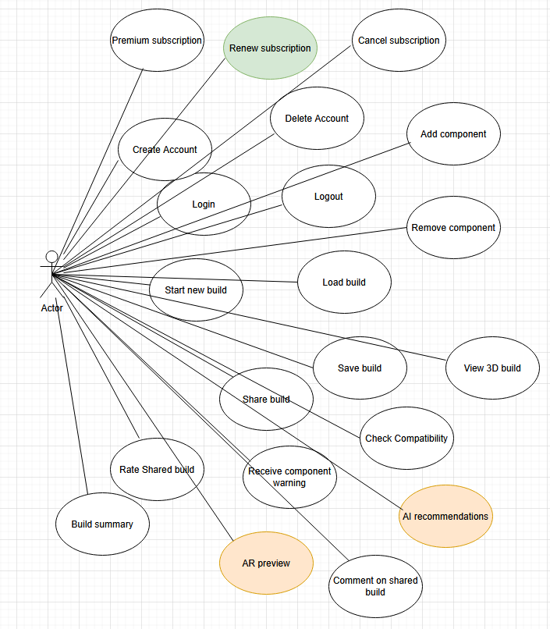

Activity Diagram

**Activity Diagram - five user cases**

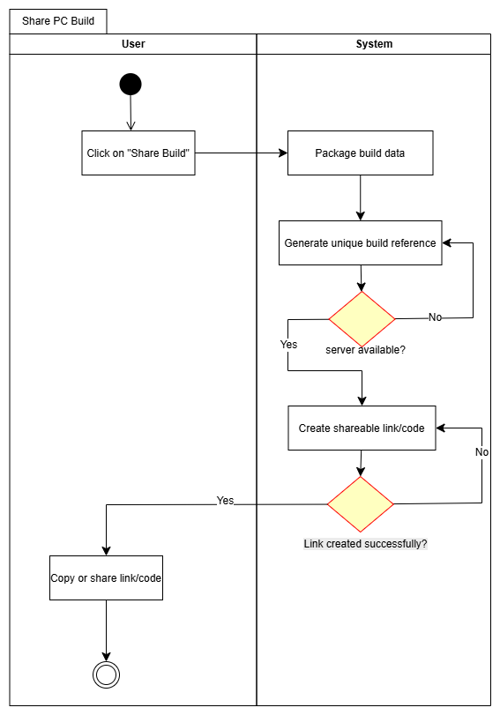

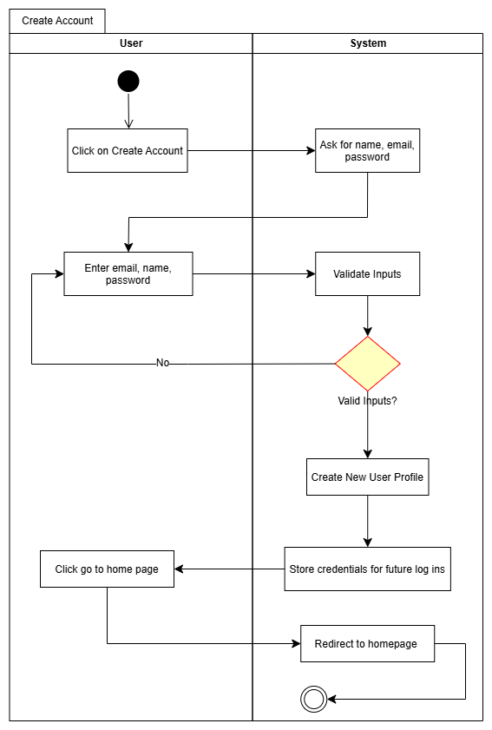

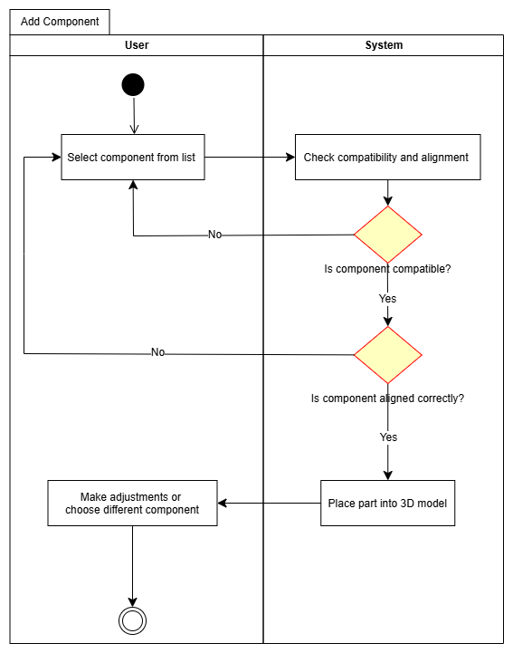

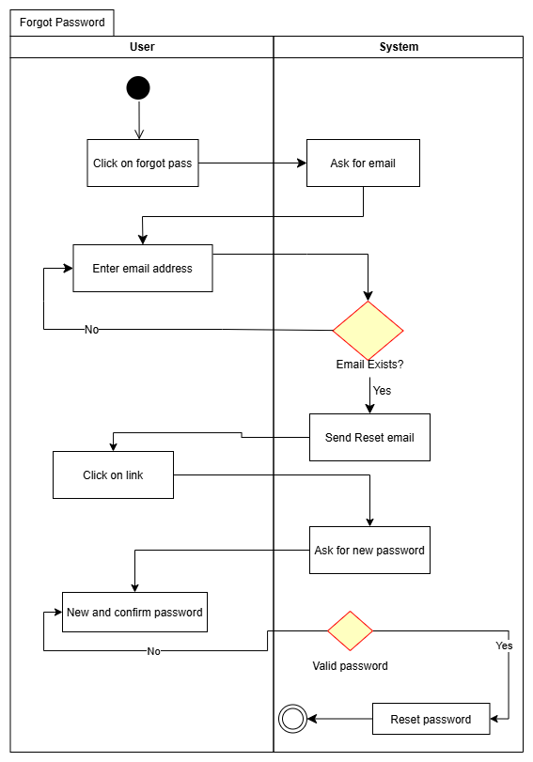

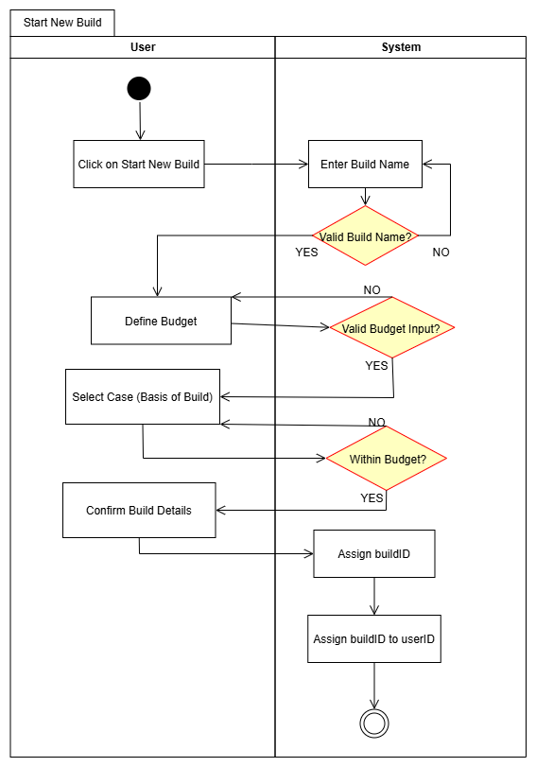

SSD (System Sequence Diagram)

**System Sequence Diagram**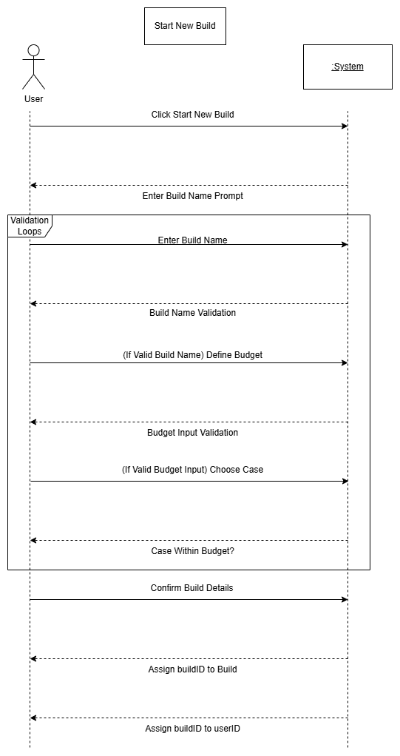

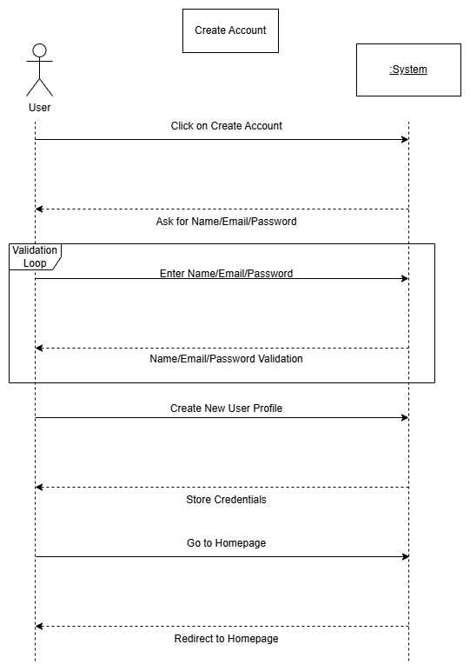

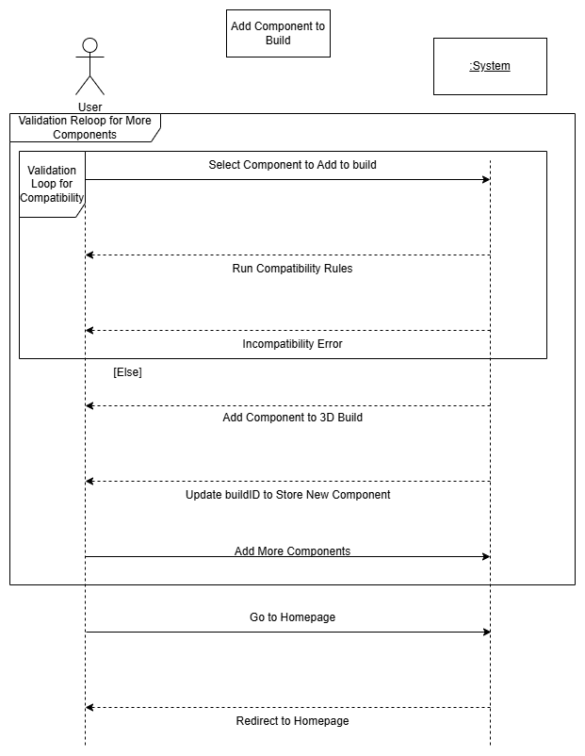

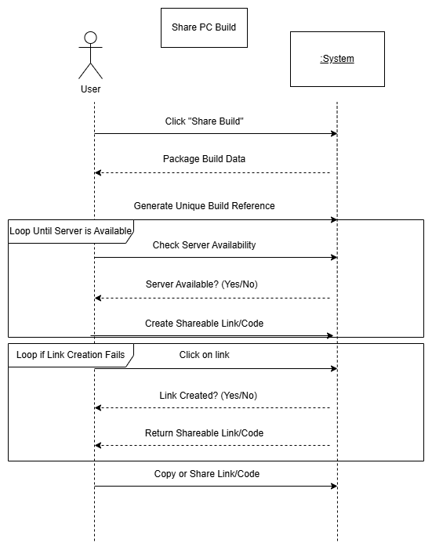

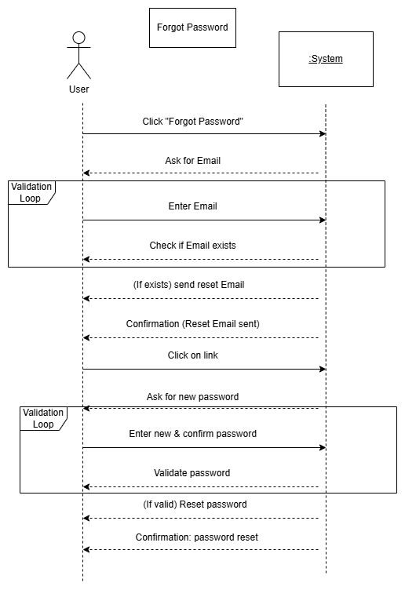

DMCD (Domain Model Class Diagram)

**Domain Model Class Diagram**

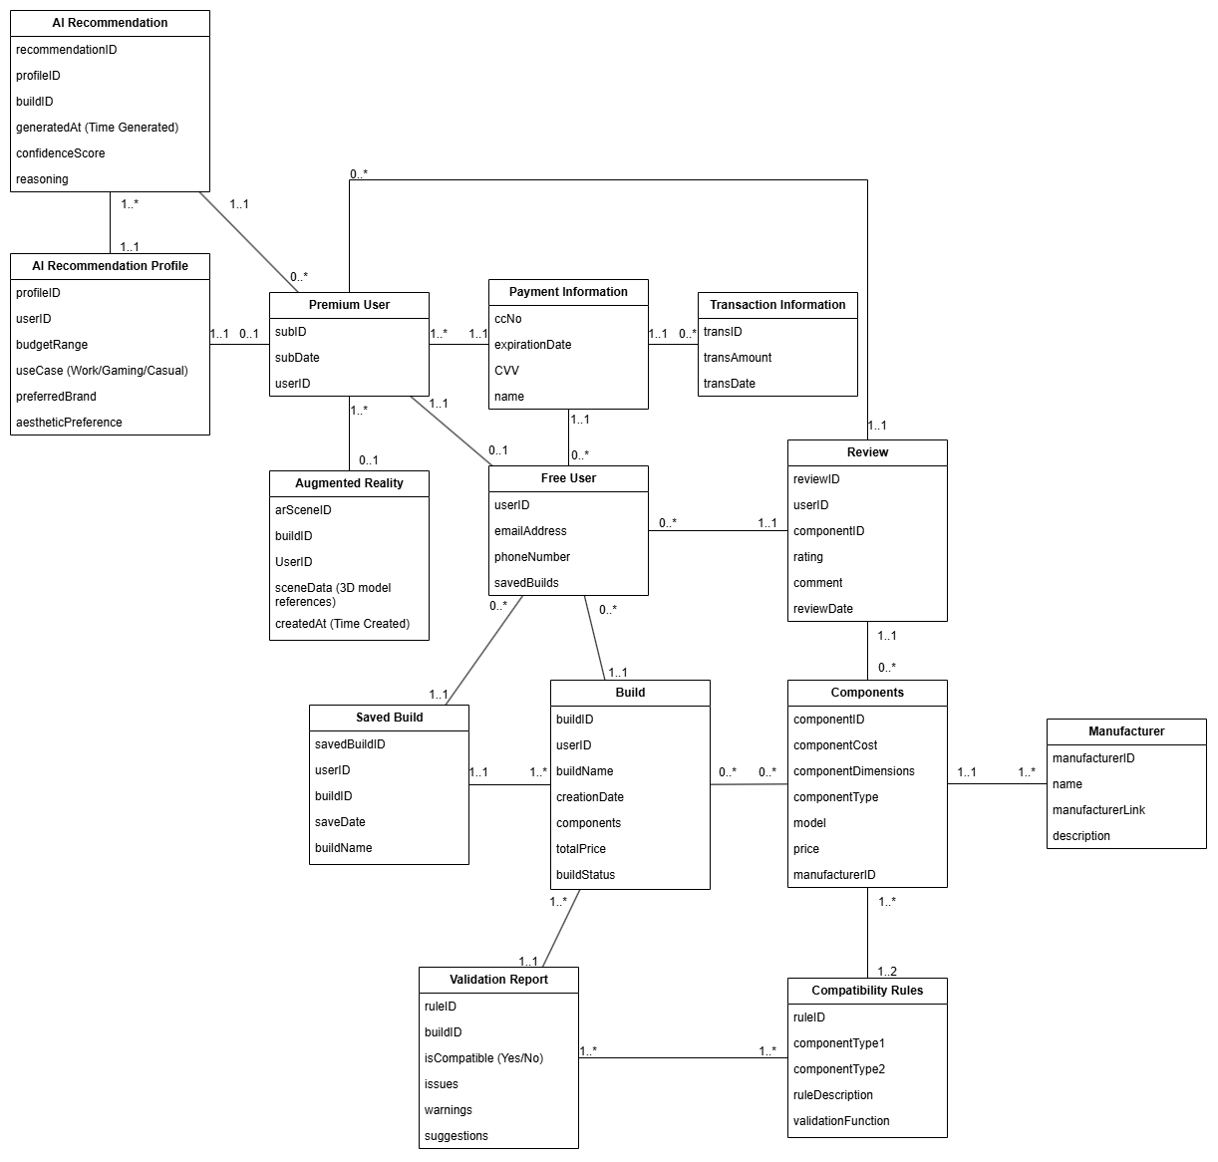

CRUD Matrix

**CRUD Matrix**

| **Use Case / Entity** | **User** | **PCBuild** | **Part** | **Compatibility**  **Check** | **Order** | **Review** |
| --- | --- | --- | --- | --- | --- | --- |
| Register/Login | C/R |  |  |  |  |  |
| Create new PCbuild | R | C |  |  |  |  |
| Add part to build | R | U | R |  |  |  |
| Check compatibility | R | R | R | C/R |  |  |
| Save build | R | U |  |  |  |  |
| Place order | R | R |  |  | C |  |
| Leave review | R |  |  |  | R | C |

GUI/Diagram screenshot

**Graphical User Interface – Running Prototype**

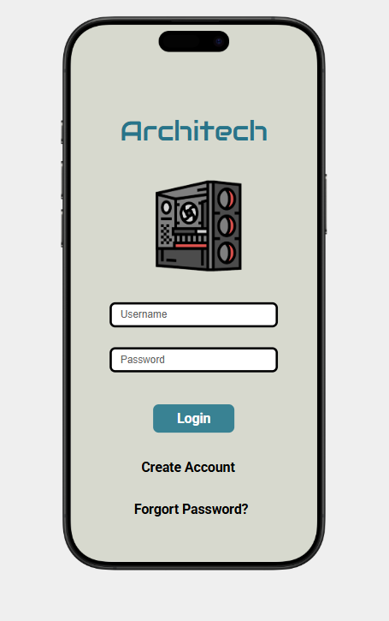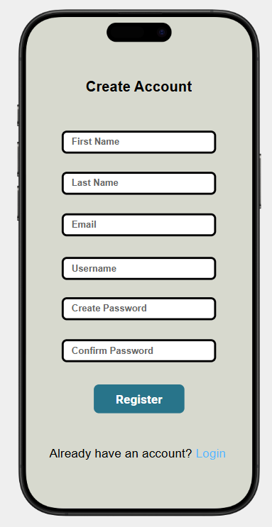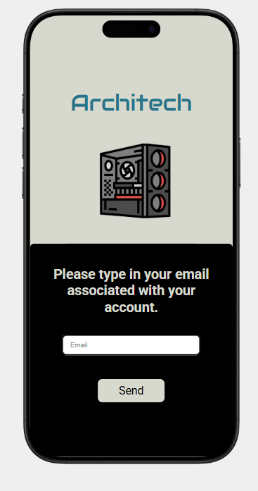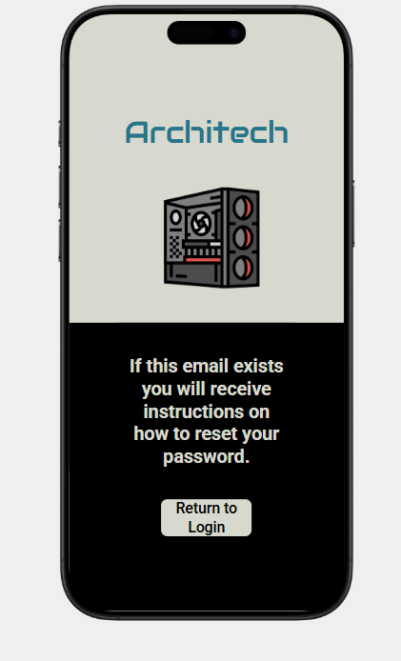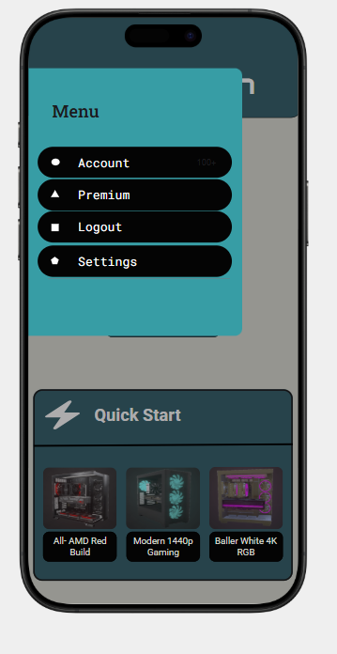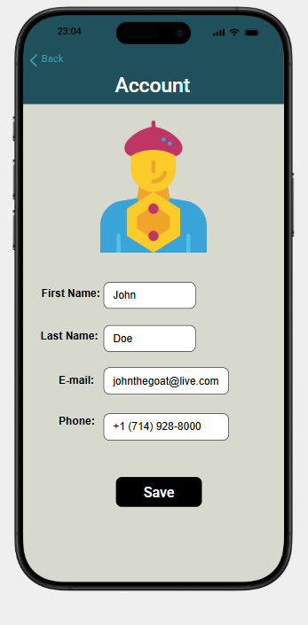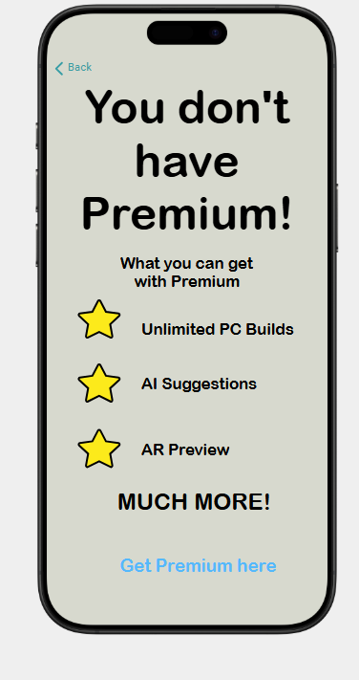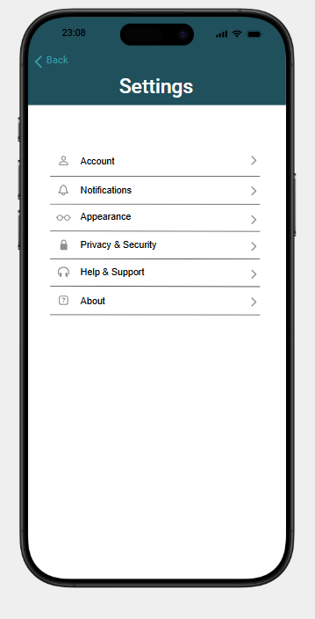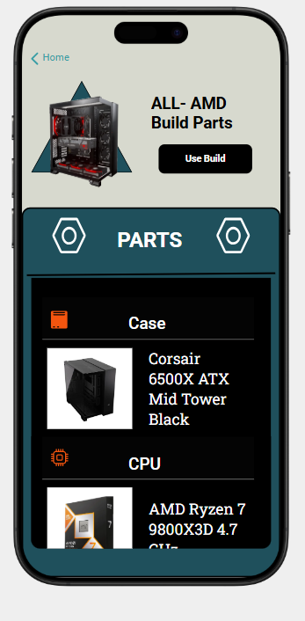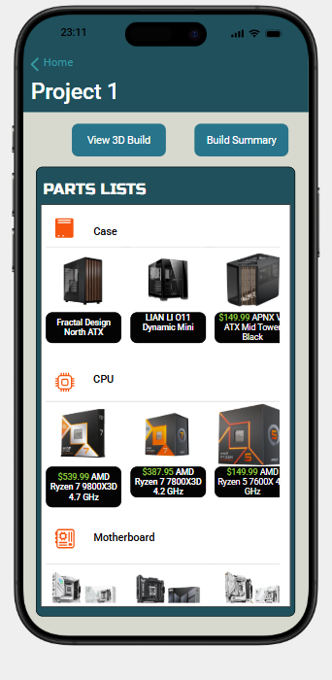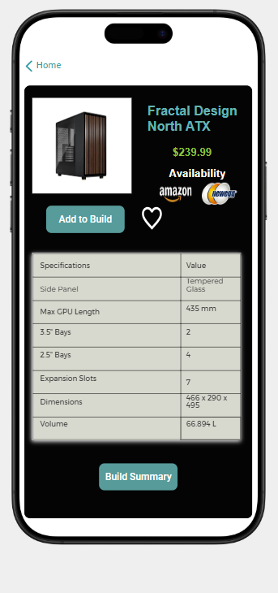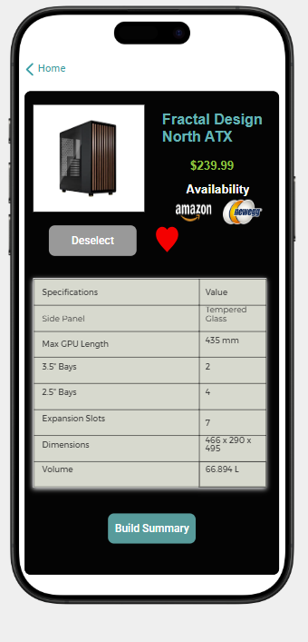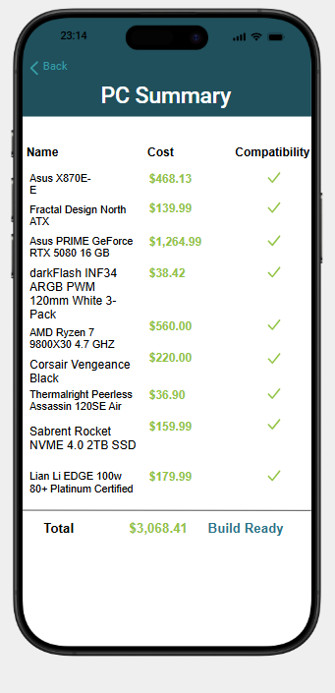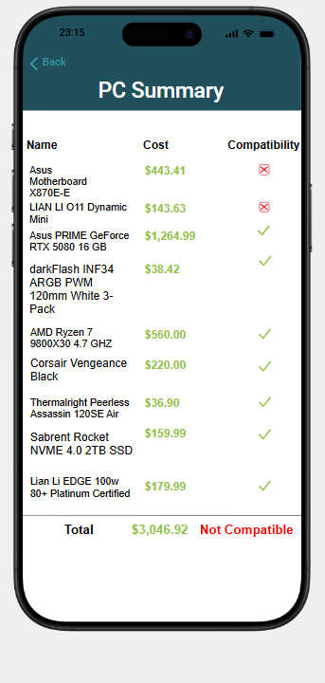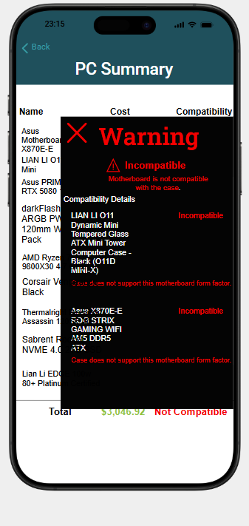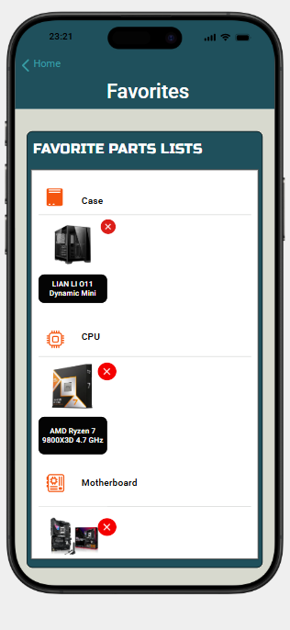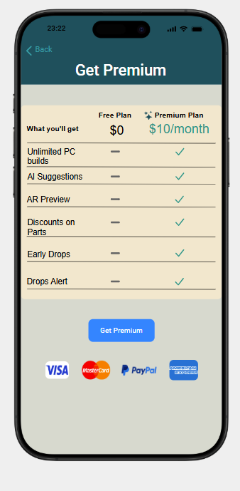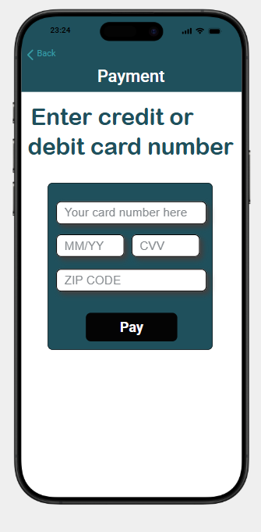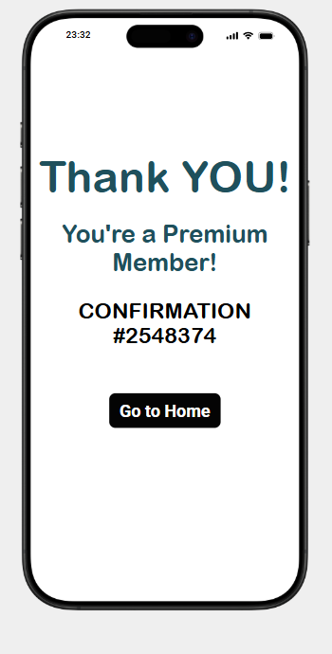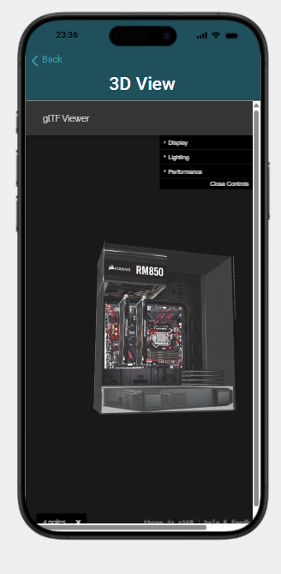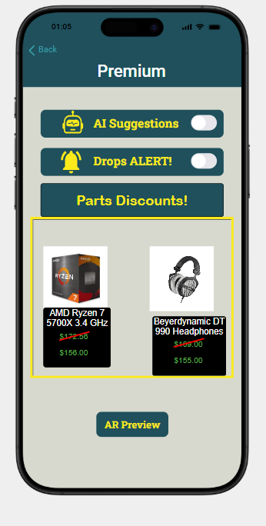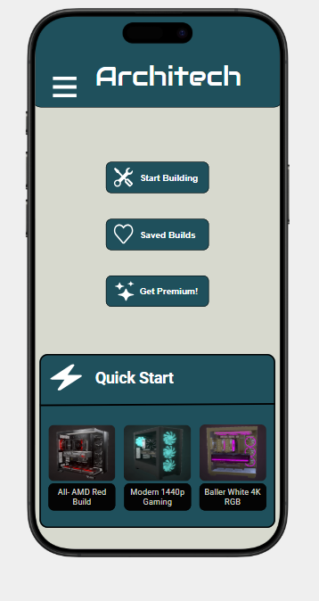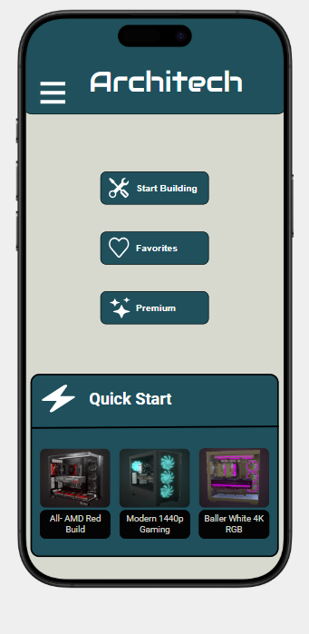

Report Conclusion/Further dev

Conclusion — ArchiTech

ArchiTech introduces a powerful method for users to plan and visualize custom PC builds through an interactive 3D environment that has real-time compatibility checks with mobile access. By addressing an ongoing issue in the PC building process, ArchiTech offers an immersive and practical solution for all users regardless of their experience.

Despite this solution, several areas require further development to enhance the app’s value, such as expanding the component database, integrating with e-commerce platforms, adding more AR features, social media features, and performance benchmarking tools.

These future improvements will allow ArchiTech to grow beyond its current role as a PC planning tool and possibly expand into different industries.